**SOLANO COMMUNITY COLLEGE**

**MT 162, ROBOTICS**

Fall, 2018

SOLANO COMMUNITY COLLEGE

ROBOTIC SYSTEMS MT-162

**LAB 4: CREATING AND RUNNING A PROGRAM**

**Catharine Crayne**

**10/22/18**

**OBJECTIVE**:

1. To learn how to create, teach, test, and execute a motion program.

**GROUP MEMBERS**

Diane and Zach

**MATERIALS**: RoboGuide and Laptop, Fanuc Robot, Box

**PROCEDURE**:

1. Power up the robot controller. Place the robot in Teach Mode.
2. Turn on Teach Pendant and change the robot’s jog speed to 25%. Set the robot to jog in the TOOL coordinate system.
3. Set the active Frames to Tool 2 and User 0. Remember [SHIFT] + [COORD].
4. Verify Tool Frame 2 is taught correctly by Jogging the robot in TOOL, yaW, Pitch, and Roll. If it is not correct, re-teach it.
5. Set the robot to jog in JOINT coordinates.
6. Create a new teach pendant program. Name the program “BOX_*your_name*”.
7. In the program DETAIL screen, what are the defaults for Sub-Type, Group Mask, Write protect, and Ignore Pause?
8. Jog the robot to it’s ZERO joint position (or close to it). Use the [POSN] key in Joint mode to help you.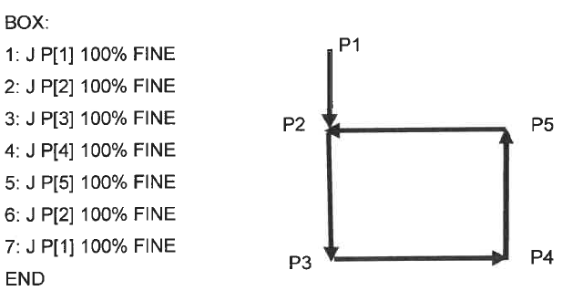
9. Teach a simple HandlingTool path that begins from the ZERO joint position P[1], outlines a box shape on the table, then returns back to P[1]. See example:
10. Test your program in STEP mode.
11. Now test the program in continuous mode.
12. Now turn off the Teach Pendant, set the Operator Panel to AUTO, and run your program in AUTO mode.

**RESULTS - DATA**

Step 7: Subtype = None, Group Mask = {1,*,*,*,*,*,*,*}, Write Protect = Off, Ignore Pause = Off

**OBSERVATIONS**

**Step 5-7 Step 8**

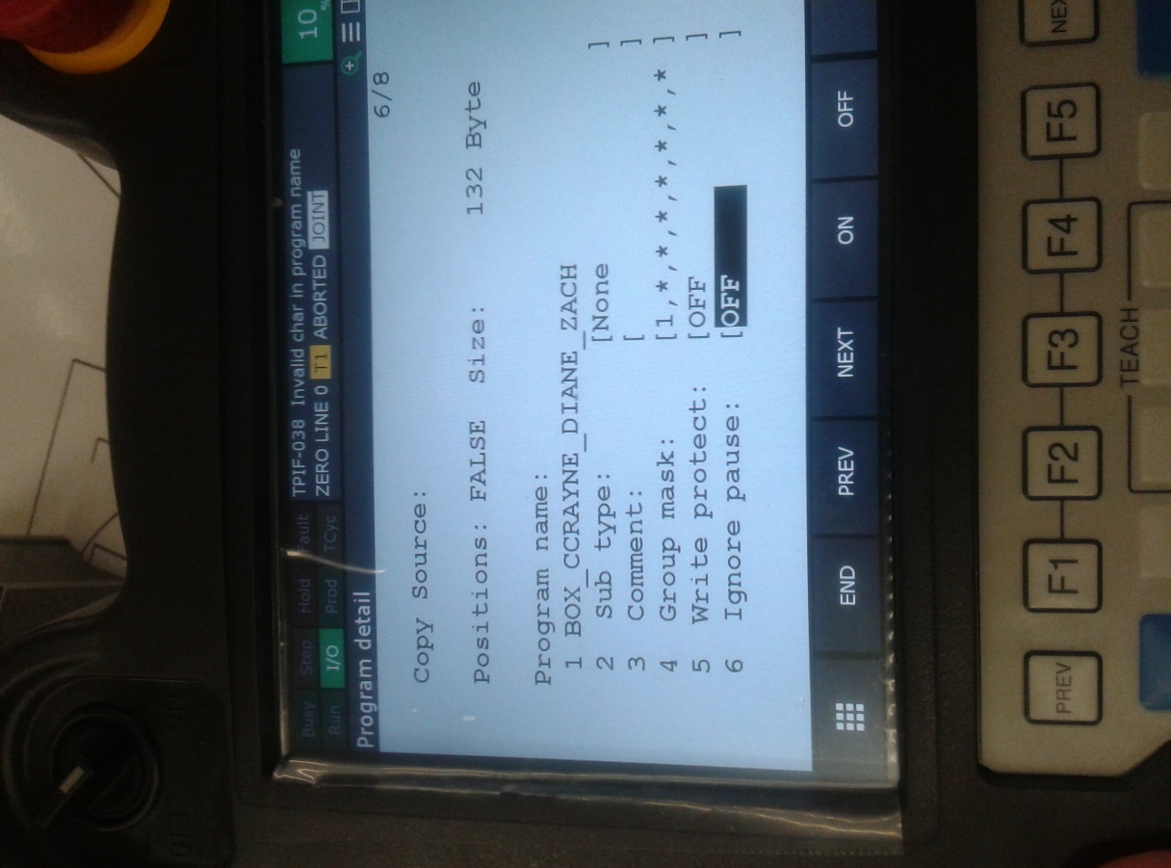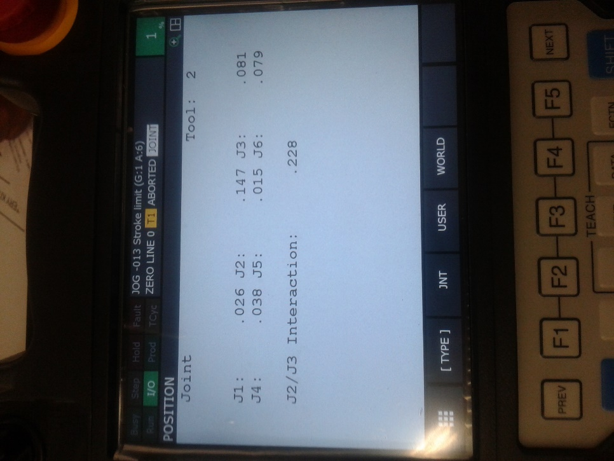

**Step 9**

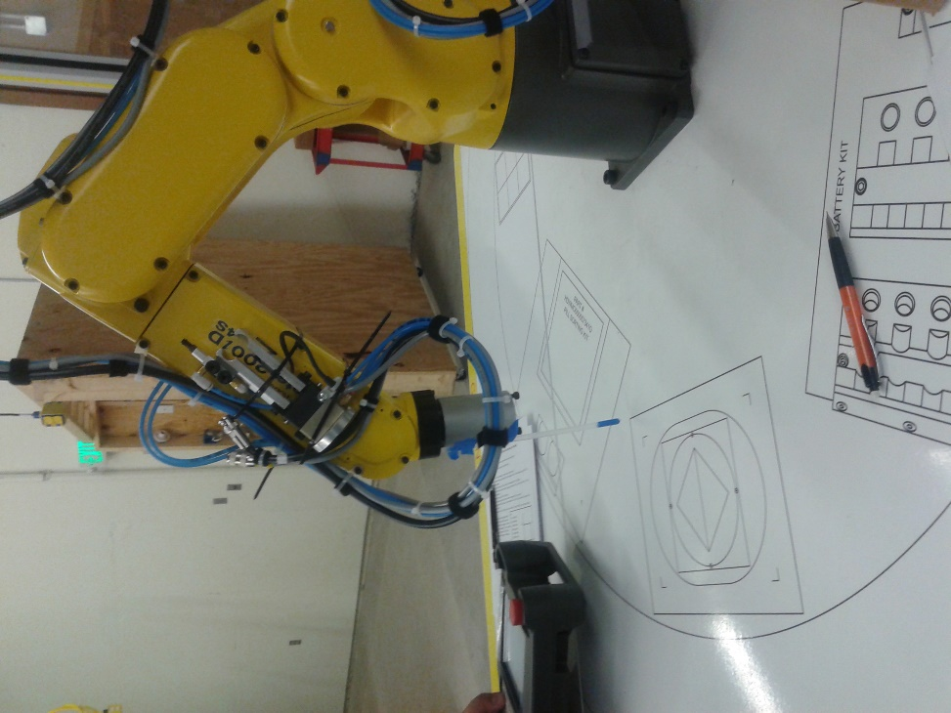

**Analysis Questions:**

1. In a Program header, what does the Group Mask refer to?

*The Group Mask points enable the corresponding motion group. The 1st entry is the robot’s 6 axis.*

1. What key combination is used to record a program point?

*[SHIFT] + [Record]*

1. What status indicator lets you know you are in STEP mode?

*The Step mode indicator turns yellow when it is on and is green when it is off.*

1. In the SYSTEM / CONFIG setup screen, there is an option to re-configure the Cycle Start button on the Operator Panel.
   1. Which setting do you choose to allow it to be used to start a program?

*Set the REMOTE/LOCAL item to LOCAL in the System Configuration Screen, select AUTO and press the CYCLE START pushbutton.*

* 1. What are the other options to Cycle Start a program?

*Single Step testing.*

* 1. Why would you use them?

*Trouble-shooting or testing before full deployment. This will allow the programmer to identify and fix any errors or misconfigurations in a safe manner.*